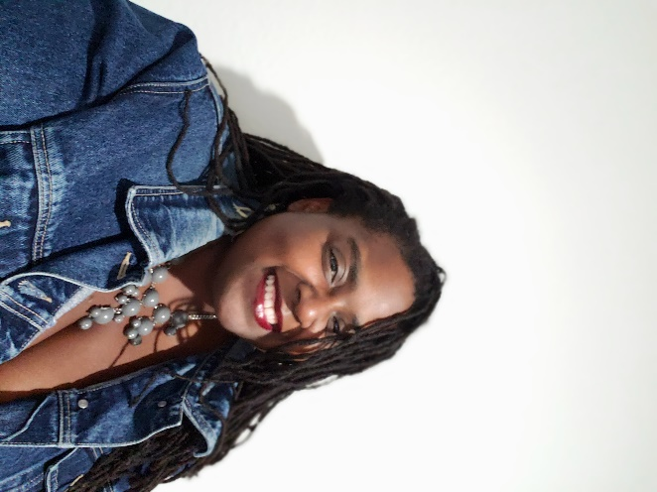
“Pure. Euphoric. Sultry.” These are all words used to describe the smooth, sweet sound of Kristin Trotty's soulful voice and vibrant flute playing. While she sings neo-soul, R&B and other genres, it's her approach to jazz standards that transports you to “days of glamorous hotel lounges and supper clubs.”
Kristin Trotty was born in East Texas. She graduated from Hawkins High School and attended Prairie View A&M University where she studied classical flute and received her B.A. in General Music with a minor in Computer Science. While at PVAMU, Trotty performed with and supported the PVAMU Marching Storm, Symphonic Band, Jazz Band and PV Concert Chorale. She also performed with Houston Ebony Opera Guild Chorus and as a soloist and chorus member at St. James Episcopal Church until graduation.
Trotty held a variety of jobs including music educator and testing coordinator, before heeding the call to perform. She cemented her standing as a performer on the Austin music scene with her debut performance at Austin’s Skylark Lounge to a standing room only crowd in 2015. "It was great to look out and see friends, family and supporters. This is what I was meant to do, and I’m going to do it as long as possible.” She has since performed at a variety of venues in Austin, San Antonio and Port Aransas accompanying groups like Austin Heat, blues songstress Andrea Dawson and her Killer Band, The Long Branch Jazz Quintet and reggae artist Crucial Prophet. Venues Trotty has played include Kenny Dorham’s Backyard (Austin), The Salvage Vanguard Theater (Austin), the Dedrick Hamilton House (Austin), Luna Lounge (San Antonio), Sahara Lounge (Austin), The Long Branch Bar (Austin), Giggidy’s (Port Aransas), The Back Porch (Port Aransas) and local art galleries. Kristin performed regularly at Dozen Street until early 2020. She has also performed at the George Washington Carver Museum and Genealogical Center (Austin) for Juneteenth and Black History celebrations, and most recently worked as a music instructor for the Carver Camps Visual Arts Summer Program.
Kristin Trotty has been involved in music most of her life. She sang in church choirs as a child and participated in marching band and music competitions in middle and high school as a musician, colorguard member and drum major. She also held a lead role her high school’s production of “Joseph and the Amazing Technicolor Dreamcoat.” In college she studied flute, piano and, briefly, voice. After moving to Austin, she returned to religious music, singing in choir, playing flute and piano. She also sang and played flute with the Austin Chapter of the Gospel Music Workshop of America for a few years before devoting her energy to jazz and neo-soul. Her musical influences include James Galway, Bobbi Humphrey, Ella Fitzgerald, Nina Simone, Billie Holliday, Etta James, Luther Vandross, Confunkshun, Chicago, the Commodores, James Cleveland and a host of other professional and amateur musicians.
Trotty performs under her given name for solo and ensemble performances favoring a trio or quartet of flute, piano, drums and occasionally bass. Her song list includes covers such as her first jazz release “It Never Entered My Mind”, Jill Scott’s “The Way”, Alanna Miles’ “Black Velvet”, Amy Winehouse’s “You Know I’m No Good” as well as jazz standards, both instrumental and vocal, made famous by Sarah Vaughn, Nancy Wilson, Nina Simone, Abbey Lincoln, John Coltrane, Sam Cooke, Bobbi Humphrey and more. Kristin has also been featured on studio recordings with the band Fentress.
Trotty’s future plans are massive. She hopes to share her music around the world through recordings and live performances. Dreams of collaborations with performers like Maxwell, Jill Scott and Erykah Badu, keep her motived while driving herself to continue developing her own sensual, soulful style. Trotty has short term goals of performances in Dallas, Houston, Austin, and San Antonio and long-term goals of traveling, studying and performing in South America and Europe. She also plans to start a nonprofit music academy for minority students helping them develop in music literacy, performance, composition and careers that are both directly and indirectly related to the music industry. Currently, she is writing her first cd project with a projected release date of May 2023.

